No Smoking / vaping policy

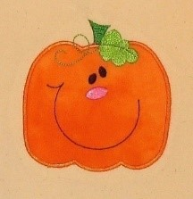

At Pumpkin Pie Childcare we are committed to promoting children’s health and well-being. This is of the upmost importance for the nursery. Smoking has proved to be a health risk and therefore in accordance with legislation, the nursery operates a strict no smoking policy within its buildings and grounds. It is illegal to smoke in enclosed places.

All persons must abstain from smoking while on the premises. This applies to staff, students, parents, carers, contractors and any other visitors to the premises.

Staff accompanying children outside the nursery, are not permitted to smoke. We also request that parents accompanying nursery children on outings refrain from smoking while caring for the children.

Staff must not smoke while wearing nursery uniform as it is essential that staff are positive role models to children and promote a healthy lifestyle. If staff choose to smoke during breaks they are asked to change into their own clothing and smoke away from the main entrance.

We respect that smoking is a personal choice, although as an organisation we support healthy lifestyles. We aim to help staff and parents to stop smoking by:
- Providing factsheets and leaflets
- Providing information of local help groups
- Providing details of the NHS quit smoking helpline - www.smokefree.nhs.uk
- Offering information regarding products that are available to help stop smoking
- Offering in-house support.

This policy also applies to electronic cigarettes.

This policy was adopted on | Signed on behalf of the nursery | Date for review
June 2023 | Lucy Grieve | June 2024

