Food Play Policy

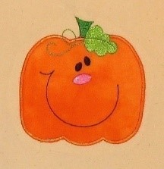

At Pumpkin pie Childcare we ensure any food we use for play with the children is carefully supervised.

We will also use the following procedures to ensure children are kept safe:
- Choking hazards are checked and avoided
- We will not use whole jelly cubes for play. If we do use jelly to enhance our play, then all jelly will be prepared with water as per the instructions and then used
- Heat treated flour will be used, where appropriate, to reduce risk of infection
- Small objects such as dried pasta and pulses will not be used for younger children
- All allergies and intolerances will be checked and activities will be adapted to suit all children’s needs, so no child is excluded
- All activities including food will be included on the planning sheets showing all allergens, so all staff and parents are aware of the ingredients
- Children’s allergies will be visible to staff when placing out food play activities to ensure all needs are met
- Any cooking activities will be checked prior to start to ensure all children are able use all the ingredients based on their individual needs
- We will not use food in play unless it enhances the opportunities children are receiving from the activity. Much of the food will be reused in other activities, especially the dry materials.

This policy was adopted on | Signed on behalf of the nursery | Date for review
June 2025 | Lucy Grieve | August 2026

https://www.food.gov.uk/safety-hygiene/raw-flour

